Data Management Plan (Iteration‐2)
Wiki Link : https://github.com/ViswasS/GDP_Group_02/wiki/Data-Management-Plan-(Iteration%E2%80%902)
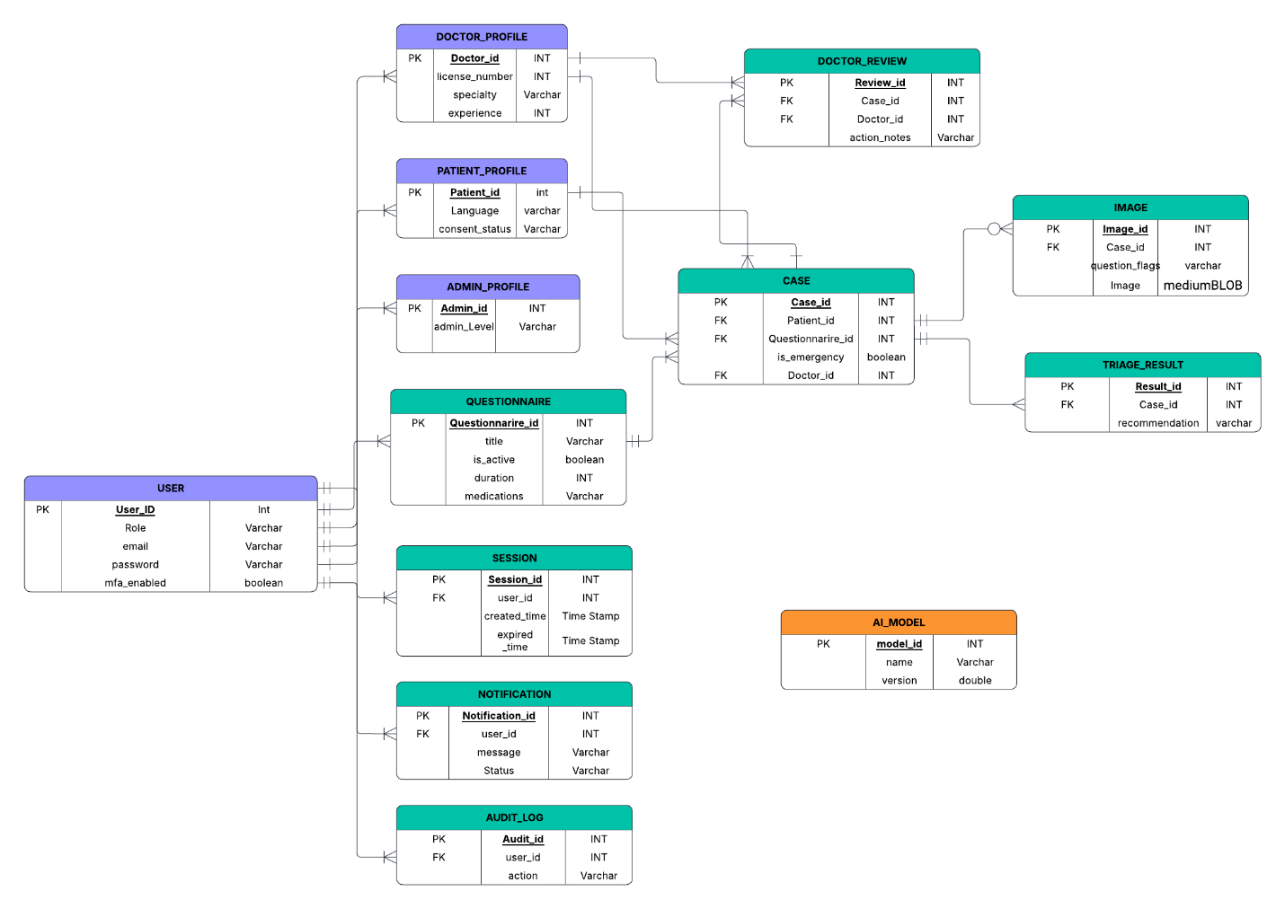

Summary of Data to be Stored
1. User
- User_ID: Identifier for each user in the system.
- Role: Represents the user's role (Admin_Profile, Doctor_Profile, or Patient_Profile).
- Email: User's registered email address for authentication.
- Password: Password encrypted to enable secure login.
- MFA_Enabled: Multi-Factor Authentication is enabled for the user.
2. Admin Profile
- Admin_ID: Identifier for each admin.
- Admin_Level: Level or authority of the admin in the system (e.g., Super Admin, Data Admin).
3. Doctor Profile
- Doctor_ID: ID for each doctor.
- License_Number: Professional license number issued to the doctor.
- Specialty: Medical specialty domain (e.g., Dermatology).
- Experience: Years of experience.
4. Patient Profile
- Patient_ID: ID for each patient.
- Language: Preferred language of communication for the patient.
- Consent_Status: Whether or not the patient has consented previously.
5. Questionnaire
- Questionnaire_ID: Unique identifier for each question.
- Title: Description of the problem.
- Is_Active: Indicates whether or not the session is active.
- Duration: Duration of the problem.
- Medications: Optional field listing out any medications used.
6. Triage_Case
- Case_ID: A unique case identifier for each triage case submitted by a patient.
- Patient_ID: The patient who submitted the case.
- Questionnaire_ID: The questionnaire associated with the case.
- Is_Emergency: Indicates whether the case is marked as an emergency.
- Doctor_ID: The doctor who is assigned to the case.
7. Image
- Image_ID: A unique ID for each uploaded image.
- Case_ID: Points to the case with which the image is associated.
- Question_Flags: Annotations or flags connecting the image to specific questions or conditions.
- Image: Binarily stored image data securely.
8. AI Model
- Model_ID: A unique ID for each AI model version.
- Name: The name of the used AI model for inference.
- Version: The deployed version number of the AI model.
9. Triage_Result
- Result_ID: A result ID unique for each triage result.
- Case_ID: Refers to the case for which the result is produced.
- Recommendation: The final AI-suggested advice or triage recommendation (e.g., "Seek care", "Monitor at home").
10. Doctor Review
- Review_ID: A review ID unique for each doctor's review.
- Case_ID: Refers to the triage case being reviewed.
- Doctor_ID: Refers to the physician performing the review.
- Action_Notes: The physician's notes, ruling, or override on the basis of the AI output.
11. Notification
- Notification_ID: A unique identifier for each notification.
- User_ID: The user to whom the notification is addressed.
- Message: Content of the notification message.
- Status: Indicates whether the notification has been sent, delivered, or read.
12. Session
- Session_ID: A unique identifier for each user session.
- User_ID: Refers to the currently logged-in user.
- Created_Time: Time stamp indicating when the session was initiated.
- Expired_Time: Time and date at which the session ended or expired.
13. Audit Log Information
- Audit_ID: Unique number for all logged activities.
- User_ID: User who took the action.
- Action: Action taken (e.g., created, updated, deleted).
Data Security Plans
1. Access Controls
- Role-Based Access Control (RBAC): Access by user role and admin level.
  - Admin: Full access to user, triage, and system logs.
  - Doctor: Access to escalated or assigned triage cases.
  - Patient: Selective access to own triage data.
- Authentication: Safe password policy with optional MFA.
- Session Control: Managed through Session table to limit and track all logins.
2. Data Encryption
- At Rest: Sensitive data (passwords, emails, images, results) encrypted using AES-256.
- In Transit: All communication encrypted using HTTPS/TLS.
- Sensitive Fields:
  - USER.password – Stored hashed and salted.
  - IMAGE.question_flags – Encrypted if it holds identifiable data.
3. Security Audits on Regular Basis
- Regular penetration testing and vulnerability scanning.
- All admin and doctor actions logged in the AUDIT_LOG table.
- Immutable logs stored for compliance purposes.
4. Backups and Recovery
- Automatic Backups: Daily cloud backup of database and image data on a regular basis.
- Version Control: Time-stamped backups for roll back.
- Recovery Policy: Supports point-in-time recovery for critical tables such as USER and TRIAGE_CASE.
5. Privacy and Compliance
- Patient consent strictly enforced using PATIENT_PROFILE.consent_status.
- Anonymized Personal Health Information (PHI) used for training AI models.
- HIPAA and GDPR compliant.
Mapping of Functional Requirements to Data Storage
1. User Registration and Management
- Linked Tables: USER, ADMIN_PROFILE, DOCTOR_PROFILE, PATIENT_PROFILE, SESSION
- Description: Stores user data, roles, and session history.
2. Submission of Triage Cases
- Linked Tables: CASE, QUESTIONNAIRE, IMAGE
- Description: Patients submit triage information and images; every case links to patient, questionnaire, and doctor.
3. Doctor Review and Decision
- Linked Tables: DOCTOR_REVIEW, CASE, AUDIT_LOG
- Description: Doctors review submitted triage cases and provide feedback or decisions. Each review activity is logged to ensure accountability.
4. Notifications
- Linked Tables: NOTIFICATION
- Description: Sends and tracks messages to users for case updates, doctor ratings, or critical alerts.
5. Auditing and Security
- Associated Tables: USER, ADMIN_PROFILE, SESSION, AUDIT_LOG
- Description: Logs all user and admin activity, session data, and system changes for transparency and traceability reasons.
6. Data Management and System Governance
- Associated Tables: AUDIT_LOG
- Description: Stores operational and administrative history for compliance, monitoring, and governance of data stored.

